The Effect of Federal Student Aid on University Tuition

Alexander Keeney

ECP 4618

Research Methods for Studying Housing, Land, and Cities

December 11 2018

# Literature Review

In 1987 the former Education Secretary of the United States William Bennett wrote a piece in *the New York Times* titled *Our Greedy Colleges,* which among other things introduced the idea of a link between increased federal post-secondary tuition aid programs and rising tuition costs (Bennett 1987). This link suggests that because colleges and universities try to better themselves, they will appropriate some amount of an increase in federal aid through increases in tuition or other means to improve the quality of their school. Those institutions that do not initially raise tuition to capture an increase in aid will need to do so at a later point in time in order to catch up to the competition that did (Gillen 2012). This hypothesis, later named the “Bennett Hypothesis,” has been debated and researched for the last several decades (Archibald, Feldman, 2012). Research in this hypothesis is relevant to the central hypothesis of this paper: Federal Post-Secondary Education Financing Programs, by their mere existence or their proliferation over the last thirty years, have led to some of the rise in cost of attendance at public universities in the United States.

Researchers have not reached a consensus on the relationship between Federal aid and cost of attendance. Even though a majority of the papers seem to agree that a link exists between the introduction or increase of federal tuition aid and a subsequent increase in cost of attendance, there is a discrepancy on which variables are relevant and in which contexts this is hypothesis is valid. VAGUE. CITATIONS? WHICH STUDIES ARRIVE AT WHICH RESULT?

Larry Singell and Joe Stone’s paper *For whom the Pell tolls: The response of university tuition to federal grants-in-aid* found no relationship between increases in federal post-secondary tuition aid and increases in cost of attendance for instate resident students at public non-profit universities. However, they did find that private universities raised their cost of attendance nearly one-to-one with increases in Pell grant funding. Furthermore, tuition costs for out-of-state students at public universities seemed to behave similarly to that of for-profit college tuition. (Singell, Stone 2007).

*Does Federal Student Aid Raise Tuition? New Evidence on For-Profit Colleges*, authored by Stephania Cellini and Claudia Goldin, uses a more inclusive definition of Post-Secondary Education Institution in order to compare schools that receive federal funding to those that do not. In order to make a direct comparison between programs with and without access to Federal aid programs the researchers compared otherwise identical Cosmetology programs at for-profit schools. They found that among the observed for-profit schools, the difference between average tuition at schools that were eligible for federal tuition assistance programs and those that weren’t was roughly equal to the average amount of federal tuition assistance given. This result suggests that the average out of pocket cost of attendance at both types of schools is roughly equal. This result also suggests that the Federal Tuition aid eligible schools had increased tuition to appropriate the full amount of the Federal Tuition aid (Cellini, Goldin 2014).

Both papers discussed above find support for the Bennett Hypothesis in the realm of for-profit post-secondary education institutions, while one finds no support for the same hypothesis in public non-profit institutions. This suggests that non-profit and for-profit schools behave differently under similar situations and should be examined individually. Many other papers suggest or explicitly state a similar observation.

Andrew Gillen, in his paper: *The Bennett Hypothesis 2.0*, addresses many of the flaws in the original hypothesis. He points out several areas of elaboration which adjust the original hypothesis to more closely fit previous empirical findings, the first of which involves the type of aid. Different types of Federal Aid affect different subsets of students and therefore have different effects on the cost of attendance. Grants, for example, only affect low income students whose willingness to pay for tuition may be below the current level of tuition. Therefore, rather than increasing the entire market demand for higher education, grants increase demand of those consumers whose willingness to pay was below the current price up to that market price. This change can be visualized as the introduction of a kink in the demand curve at the current price of tuition. In this paper he also points out the inelasticity of supply due to enrollment constraints, and the competition among institutions to maintain reputation and a high volume of applicants each year. (Gillen 2012)

Another complication to estimating the link between federal tuition aid and cost of attendance is the difference between resident and non-resident costs. Non-residents of a state typically pay more tuition at a state-funded university than resident students. The Bennett Hypothesis is based on the institution’s need to raise revenues, which based on the above discussion of in and out of state student tuition costs, can be achieved another way. If Institutions can raise additional revenues by accepting more out-of-state students rather than increasing tuition prices, then the Bennett Hypothesis may have less support. Michael Rizzo and Ronald Ehrenberg (2004) found that public institutions do not use out-of-state enrollments to increase revenues. Rather, they found evidence of falling out-of-state tuition prices during times of lower quality of in-state applicants as measured with SAT scores. This result suggests that these institutions were using non-resident applicants as a source of applicant quality rather than additional revenue (Rizzo, Ehrenberg 2004).

The federal tuition aid programs addressed in the original Bennett Hypothesis were given on a need basis, rather than on a merit basis. Therefore, the original hypothesis and much of the following research focused on scholarships, grants, and loans given to low-income students. This research focus has different implications on overall tuition level compared to merit-based scholarships available for all students (Gillen 2012). The effect that merit based scholarships have on tuition setting was researched in *Tuition-Setting Authority and Broad-Based Merit Aid: The Effect of Policy Intersection on Pricing Strategies.* In their paper, the researchers found that institutions without legislatively constrained tuition levels increased tuition and fees following the adoption of broad-based merit aid. (Kramer, Ortagus, Lacy, 2018).

João De Mello and Insper Isabela Ferreira Duarte find direct support for the original Bennett Hypothesis by looking at the introduction of “Fundo de Financiamento Estudantil,” (FIES) in Brazil. FIES is similar to the United States’ federal student loan program and was originally introduced in 1999 and gained popularity over the course of the next 10 years. Their paper uses Brazilian census data from 1995 – 2012, as well as College-level data on program applicants and enrollees, and Salary and wage data. They found that the availability of credit did have an effect on tuition, specifically it lowered Demand-Tuition Elasticity (Mello, Duarte 2015).

Since education institutions compete for the best applicants with merit scholarships, applicants receiving these scholarships have a lower willingness to pay than less qualified applicants for the same education (Archibald, Feldman, 2016). Andrew Gillen’s theoretically oriented paper explores this idea in another context (2012). In his second adjustment to the original Bennett Hypothesis he discusses how tuition caps and enrollment limitations can lead to the same tradeoff between quality of applicants and revenue. Beginning with a model of a single university and giving applicants tuition aid, leads to an increase in demand, a higher tuition cost and a larger enrolment. However, because universities have an upper enrolment limit, the tuition would increase further while quantity would remain unchanged. In many cases, tuition at state-supported universities is capped at a certain level by the legislature, which leads to a shortage of enrolment spots and a surplus of applicants. Faced with a surplus of applicants, the university will fill its seats with the best applicants it can and without necessarily intending to, trade some additional revenue for the increased student quality (Gillen, 2012).

Larry Singell and Joe Stone find evidence that in-state tuition is unaffected by increases in federal tuition aid while out-of-state tuition raises in amounts roughly equal to increases in Federal tuition aid (Singell, Stone, 2007). However, Michael Rizzo and Ronald Ehrenberg find evidence supporting the opposite conclusion. In their paper they present evidence that in-state tuitions increase with increases in federal tuition aid and out-of-state tuition is correlated with the quality of in-state applicants. (Rizzo, Ehrenberg, 2004)

Given the distinction between for-profit, non-profit, public, and private universities and colleges, carefully controlling for institution type in further research will be important. Quality, or perceived quality, of each institution should also be controlled for in further research because of its effect on applicants’ willingness to pay.

# Methodology

## Introducing the Model

The model below is used to estimate the effect of federal student aid on tuition costs. It states that tuition costs will be determined by: Average Pell Grant Amount, Average undergraduate Federal Student Loan Amount, Quality Control Factor, and Private Status. The first two variables: Average Pell Grant Amount and Average undergraduate Federal Student Loan Amount are the intervention variables and the main focus of this study. The remaining 3 variables are controls for other sources of variation in tuition prices across the country over an eight-year period from 2009 to 2016.

*Tuition Costs*i, j *= + MPGA*i,j *+ MUFSLA*i,j *+ Ranking*i, j *+* +*+*

The availability of data on this subject has strongly influenced the method of evaluating the hypothesis. In a perfect world a lab-like experiment would be performed where different groups of universities were given different amounts of aid and their tuitions were compared after a predetermined number of years. For obvious practical and moral reasons this is not possible. Alternatively, variations in these variables have occurred naturally over time and the relationship between them can be estimated.

The data used in this study is publicly available from the United States Department of Education and US News and World Reports.The scope of this study is both cross sectional: including variation between universities, and time series: including variation over time. The subscripts following each variable name in the model equation indicate the dimensions in which they vary. The subscript “i,” represents years, and the subscript “j,” represents universities. For example, Ranking i, j represents the quality control factor at the jth school, on the ith year. Not all variables vary in both dimensions, Public Status is constant over time and varies between universities. In the model used for testing, inflation is not an independent variable. Rather, the response and two intervention variables are scaled to represent their value in constant 2016 dollars. This change is represented in the model with the prefix “Constant_,” attached to the adjusted variables.

The model of Tuition Costs will attempt to test the Null Hypothesis: Increases in the maximum federal student aid amounts are not related to cost of attendance at US Post-Secondary Education Institutions. The Alternative Hypothesis is: Increases in the maximum federal student aid amounts are positively related to cost of attendance at US Post-Secondary Education Institutions. If sufficient evidence is found against it, the Null Hypothesis may be rejected in favor of the Alternative Hypothesis:

## Variable Descriptions

The Response variable “Tuition Costs,” will be measured as the list price of tuition and fees. Another commonly used measure is Net Tuition, which is the list price of tuition and fees less any federal aid in the form of Pell grants or federal loans. This measure can be averaged to give: Average Net Cost of Attendance, which is commonly used as a measure of average out of pocket cost to the student. While this measure is important because it represents the cost facing the student at the time of enrolment decisions, it would fail to answer the central question of this study: are universities raising rates in response to increases in federal aid? Because of this, List price of tuition and fees is the best measure of Tuition Costs.

The treatment variables, *Average Pell Grant Amount for First Time Freshmen* and *Maximum Undergraduate Federal Student Loan Amount for First Time Freshmen*, vary over time and cross sectionally between universities. Based on the Literature review increases in both of these forms of aid may have led to increases in tuition costs. Data for the average Pell Grant Amount for First Time Freshmen and the Maximum Undergraduate Federal Student Loan Amount for First Time Freshmen is available going back to 2009.

Quality Control Factor in the general model is a label given to two variables used to measure University Quality: The US News and World Reports Annual National University Rankings, and the number of Applicants. Each school in the data set will have a ranking for each year, these vary between schools and over time. Because this list is a well-known ranking of schools, a lower spot on the list could lead to more demand for a particular university which may have a positive effect on list price of tuition. Based on this, the variable should have a negative effect on list price of tuition. The number of Applicants similarly measures the demand for that university’s education. Because these variables seem to measure the same phenomenon, demand for a particular university, they may be highly correlated and therefore introduce multicollinearity to the model. This will be measured in the *Data Exploration* section below.

The last control variable is Private Status. The data used in this study contains both public and private schools and this variable will attempt to control for variation between the two groups. The inclusion of this variable may not sufficiently control for all of the variation between the two groups because there could be an interaction effect with another variable. Given enough data, it may be ideal to run two separate regressions for the two groups and compare estimated coefficients of each group.

|  |  |  |  |  |
| --- | --- | --- | --- | --- |
| **Variable Name** | **Definition** | **Role** | **Estimated Effect(+/-)** | **Data Source** |
| List Tuition | The listed tuition price of each university for each year. | Response | N/A | Integrated Postsecondary Education Data System |
| Constant_APGF | Average Pell Grant amount per first time Freshman student | Intervention | + | Integrated Postsecondary Education Data System |
| Constant_AFSLF | Average Federal Student Loan amount per first time Freshman student | Intervention | + | Integrated Postsecondary Education Data System |
| Ranking | National Ranking of each university per year. | Control | - | US News and World Reports |
| Applicants | Number of potential students applied to each university per year. | Control | + | Integrated Postsecondary Education Data System |
| Public Status | 0 = Private  1 = Public | Control | - | Integrated Postsecondary Education Data System |

# Data Exploration

Before any formal analysis can be done, a preliminary understanding of the dataset in question should be achieved. This process includes viewing the distribution of each variable as well as a scatter plot and correlation coefficient of every combination of variables.

The matrix labeled “Pairwise comparison Matrix,” includes a scatter plot of every combination of variables. A histogram of each variable’s distribution is located at the intersection of that variable on each axis. *Constant_Tuition*, the response variable located in the top left corner, appears to be distributed in a barbell pattern, with two modes at opposite ends of the distribution. The two intervention variables: *Constant_APGF* and *Constant_AFSLF,* appear to approximate a normal distribution however, Constant_AFSLF is slightly right-skewed with several outliers. Two of the control variables, Rank and Private, are uniformly distributed across their respective domains, while Applicants looks like a heavily right skewed bell-curve.

Below is a table titled “Correlation Matrix,” which gives the correlation coefficient, to each pair of variables. Correlations among the predictor variables is low, with the highest being .342 between Constant_APGF and Applicants. The Private variable has the strongest correlation with the response variable with a coefficient of 0.945.

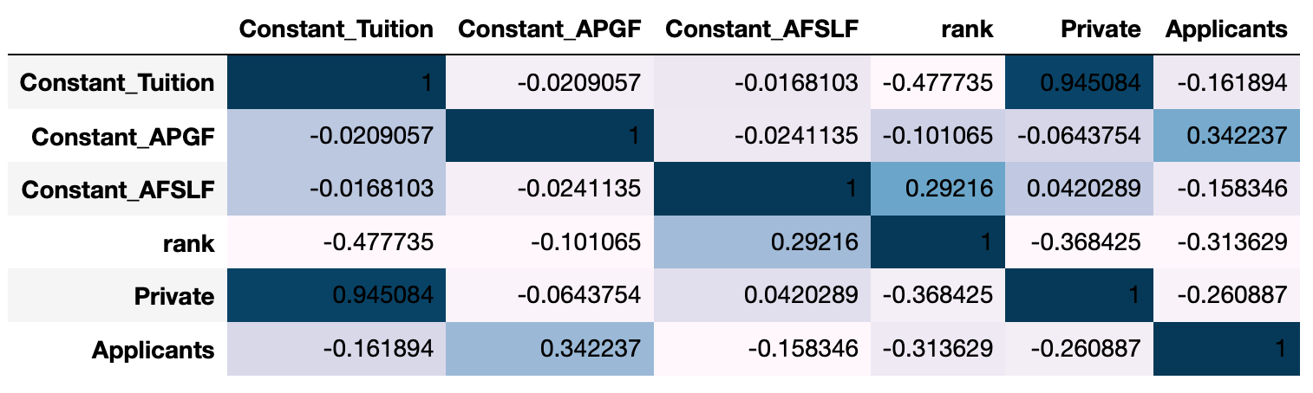

In many of the scatter plots below, two clusters can be made out. These two groups of observations turned out to be clusters of public and private schools. Examining each group separately reveals differences between these groups that go beyond the list tuition prices. Compared to public institutions, private school federal student loan amounts tend to be more variable. This can be seen by comparing the variance in Constant_AFSLF of each group of schools in Appendix D.

### Pairwise comparison Matrix

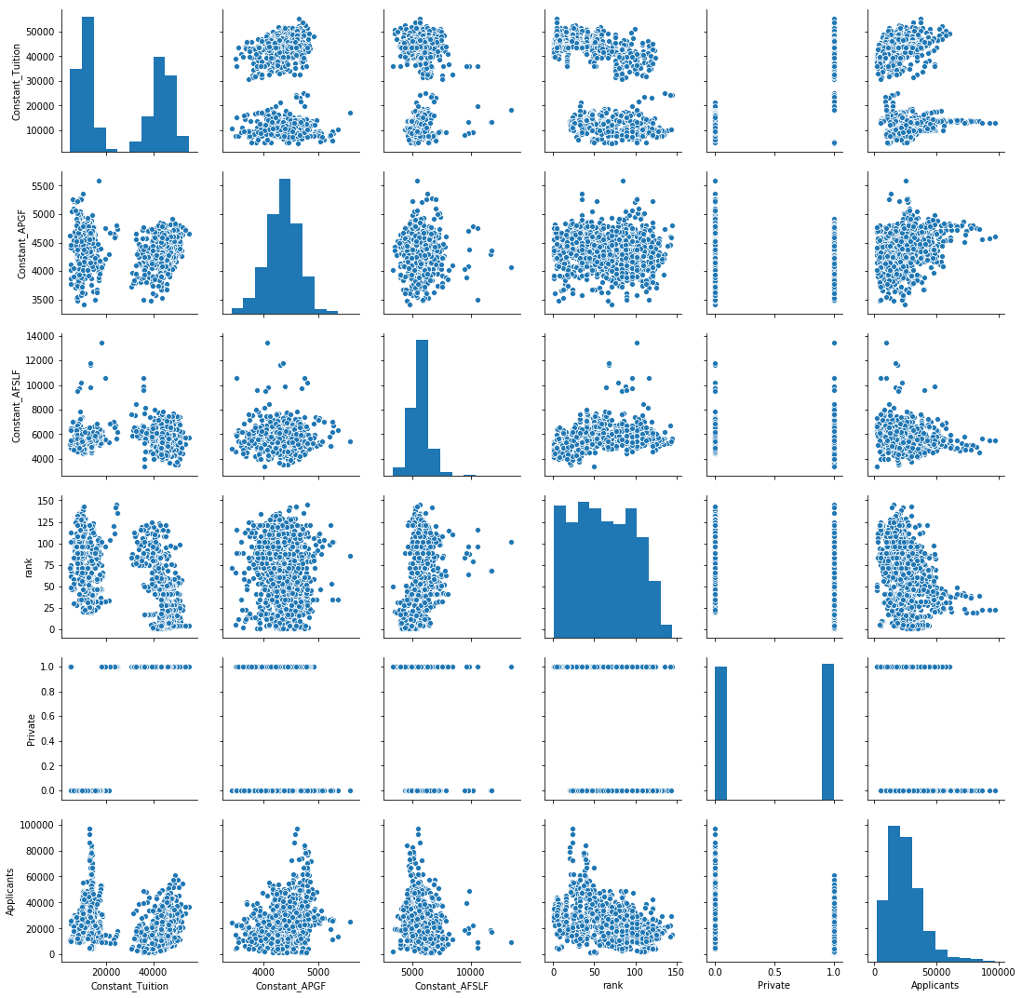

# Formal Modeling

Ordinary Least Squares Regression was used to test the models and hypothesis in this study. Many models were run using the Python language and the Statsmodels, Pandas, Numpy, Matplotlib, and Seaborn packages. For each model, a regression output and several residual plots are produced. Additional output and associated code is available in the appendix however, relevant output is listed below as well. The first model includes all five predictor variables and all observations.

|  |  |  |  |
| --- | --- | --- | --- |
|  | Model 1: All Schools | Model 2: 2 Schools Removed | Model 3: Removed Federal Loans |
| Constant_APGF | 0.8194  (0.137) | 0.8404  (0.026)** | 0.8350  (0.027)** |
| Constant_AFSLF | -0.2261  (0.227) | -0.1006  (0.454) |  |
| Applicants | 0.0311  (0.024)** | 0.0238  (0.011)** | 0.0238  (0.010)*** |
| Rank | -60.0929  (0.000)*** | -47.1035  (0.000)*** | -47.9331  (0.000)*** |
| Private | 2.997e+04  (0.000)*** | 3.113e+04  (0.000)*** | 3.11e+04  (0.000)*** |
| Adjusted R2 | 0.913 | 0.960 | 0.960 |
| F-Statistic | 2070. | 4687 | 5861 |
| Observations | 984 | 968 | 968 |

The first model above is influenced heavily by large negative outliers with high fitted values. There are 16 of these large-residual observations, made up of two schools over each year in the dataset: Howard University and Brigham Young University-Provo. For an unknown exogenous reason, these two schools have much lower list tuition, in each year from 2009 to 2016, than the model would have predicted. This can be seen in the first residual plot of Appendix A; there are several points that lie significantly outside of the range of the rest of the observations.

The second model attempts to remedy the issues of outliers present in the first. Assuming that there is something exogenous to this model that is causing these large outliers, the two schools listed above were removed. With these 16 large-outlier points removed, the data more closely fits a linear model. Interestingly, while the Pell Grant Variable becomes significant at the 5% significance level, the Federal Student Loan variable loses some of its explanatory power. Coefficients and p-values for the control variables stay roughly the same. The residual plots for this model, located in Appendix B, suggest a much better fitting model. The residuals appear to be homoscedastic and the assumption of normality appears to met. There are also very few points with high leverage, suggesting that the above predicted coefficients are not skewed by a relatively few number of observations. The last model removes the Federal Student Loan variable and further improves on model 2.

The significant difference between public and private school’s list tuition can be seen in the pairwise comparison chart in the Date Exploration section above. This difference is further supported by the large *Private* coefficient and low associated P-value in the regression models. The first three models assume a simple “elevator effect,” for binary variables. Put another way, in the models above, a pair of otherwise equivalent public and private schools would have a constant difference regardless of what the values of the other variables are. In order to model a more complex relationship, new models were run for public and private schools separately.

|  |  |  |
| --- | --- | --- |
|  | Model 4: Private Universities | Model 5: Public Universities |
| Constant_APGF | 3.4648  (0.000)*** | -1.1740  (0.004)*** |
| Constant_AFSLF | 0.0826  (0.677) | 0.1756  (0.326) |
| Applicants | 0.0374  (0.013)** | 0.0431  (0.000)*** |
| Rank | -63.5344  (0.000)*** | -19.7319  (0.000)*** |
| Adjusted R2 | 0.377 | 0.119 |
| F-Statistic | 73.40 | 17.42 |
| Observations | 480 | 488 |

While these two models have lower Adjusted R2 and F-Statistics than the previous three models, they offer new insight into this data. Based on these two models, we can further confirm that the average Federal Student Loan variable is not significant in this sample and that the other two control variables are significant in this sample. The more interesting result is the difference between the average Pell Grant variable in these two models. In the private universities model the coefficient is positive, suggesting that higher amounts of Pell Grants are associated with higher tuition levels in private schools, whereas the opposite is true for public universities. This difference in effect of a variable on each group could not be seen in the previous models.

# Discussion

The results of the data exploration and formal analysis show one result quite clearly, there is a notable difference between public and private universities. This difference could extend beyond tuition levels to the way that universities react to varying amounts of Pell Grant funding. These results are suggestive of Larry Singell’s and Joe Stones findings: private universities raise tuition prices with increases in Pell Grant Aid.

It is important not to extrapolate these findings into new domains or outside of the range of data; For example, these results have little to no relevance to For-Profit universities. However, these results could be relevant to other Non-Profit Universities in the United States with similar rankings.

# Appendix A: Model 1 Residual Plots

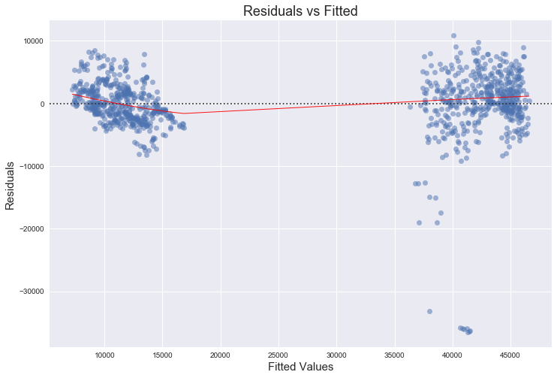

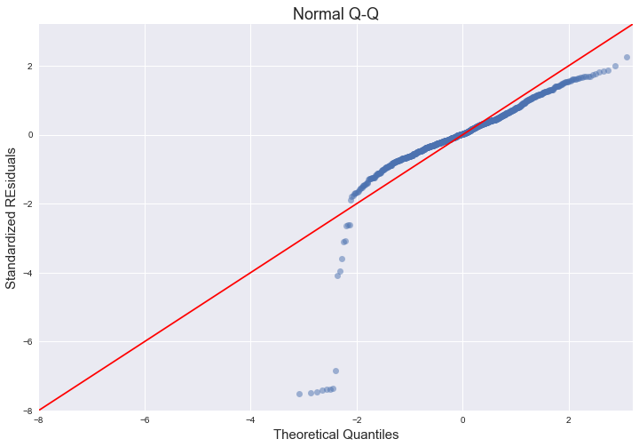

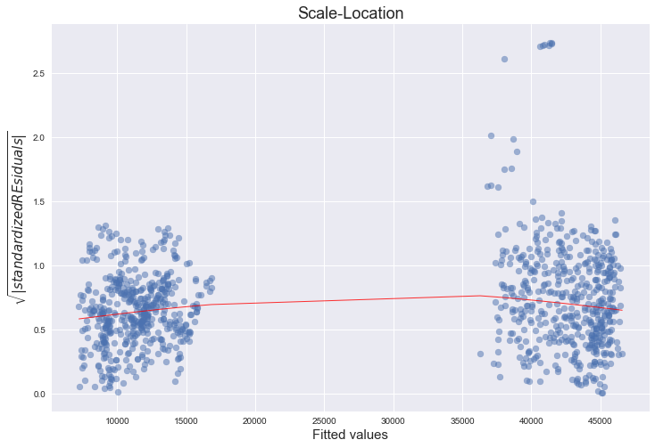

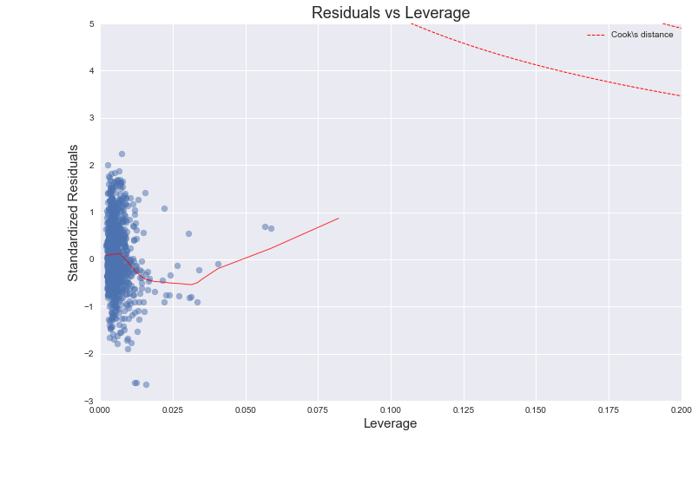

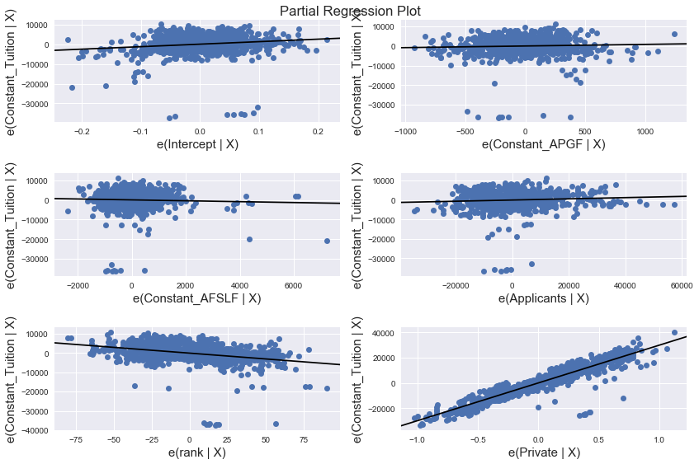

# Appendix B: Model 2 Residual Plots

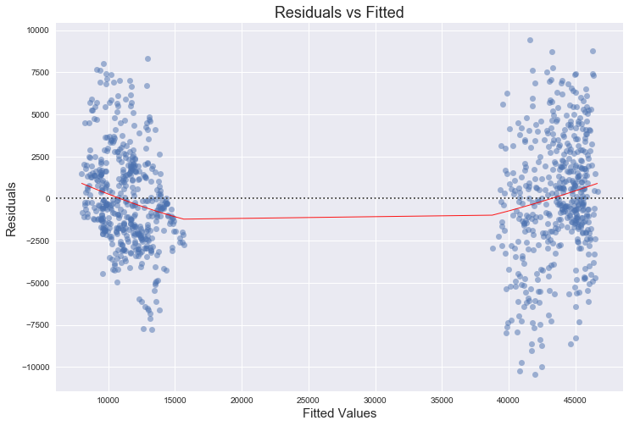

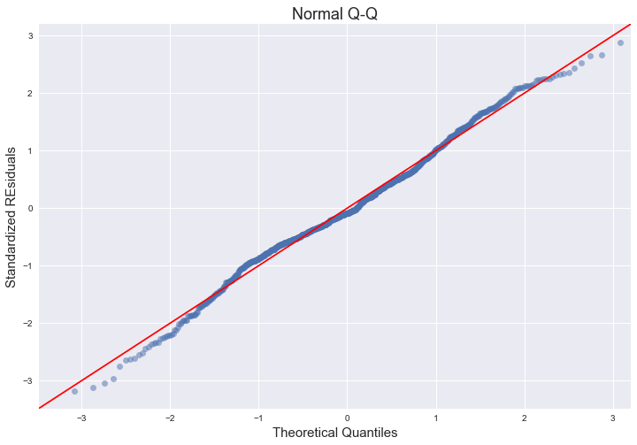

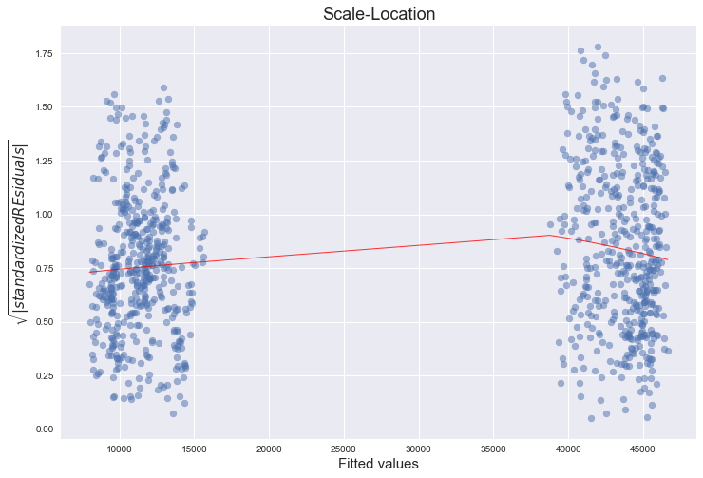

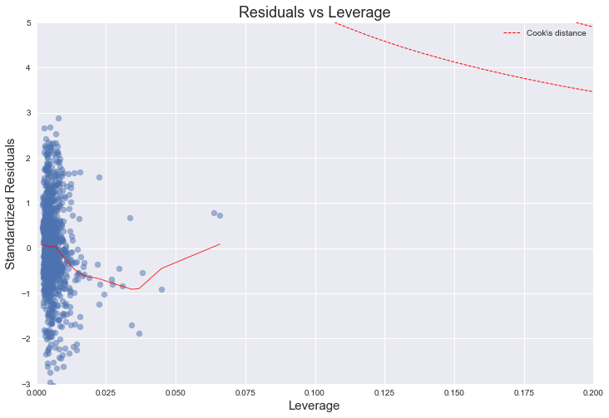

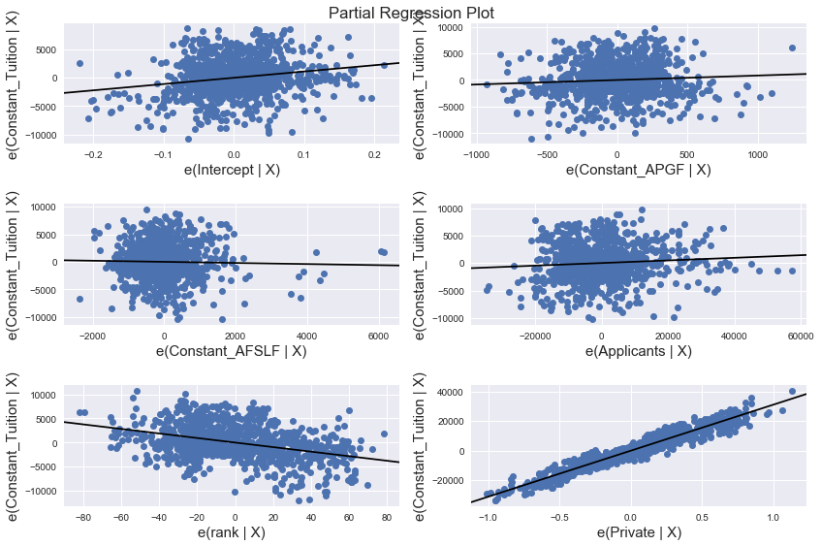

# Appendix C: Model 3 Residual Plots

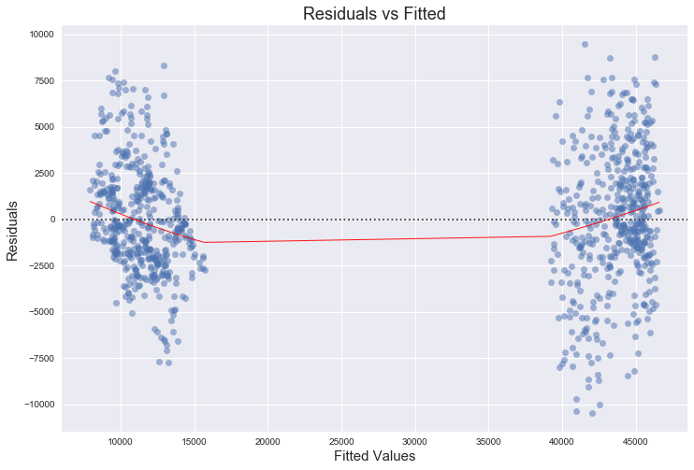

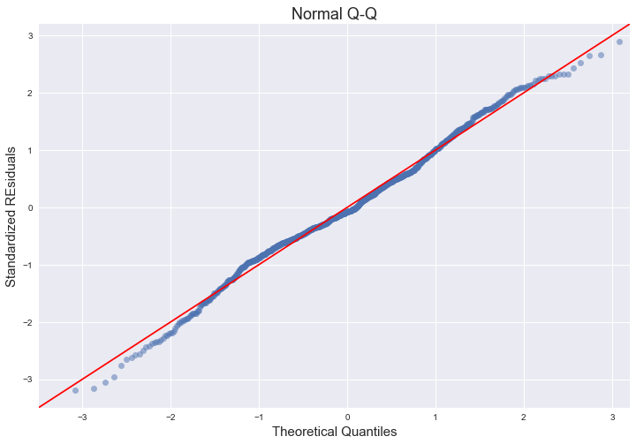

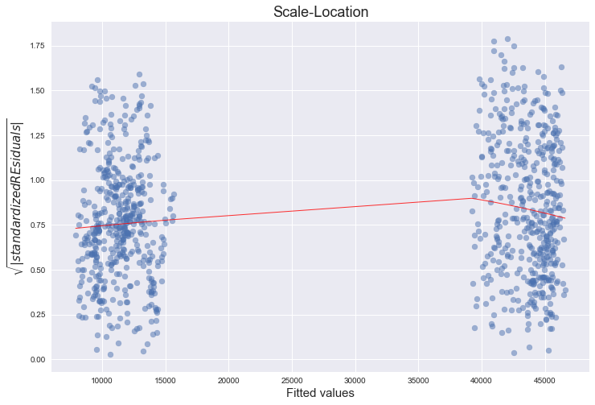

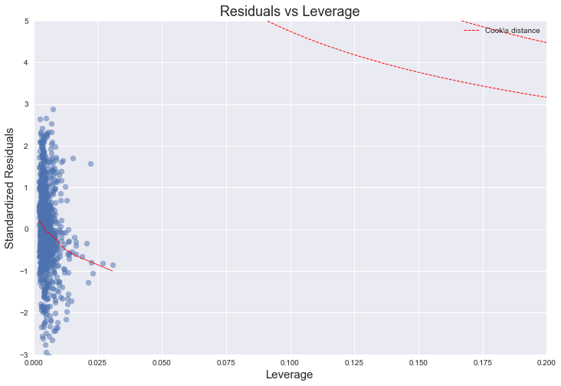

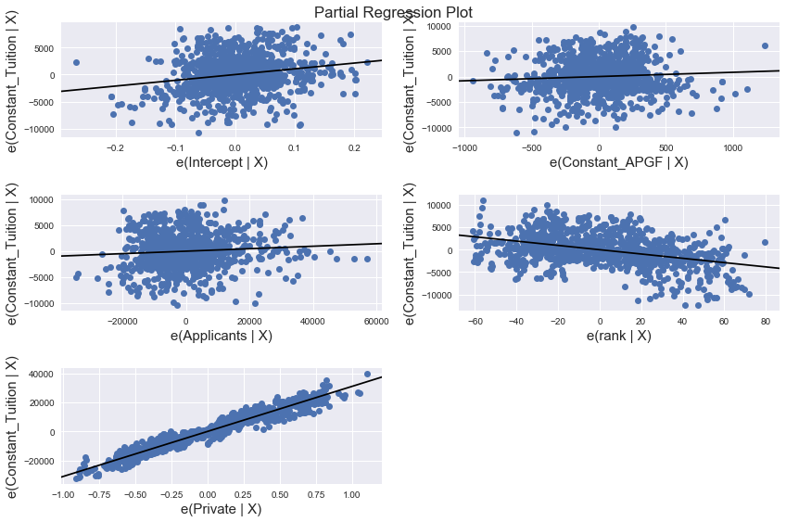

# Appendix D: Comparison of Public and Private Schools

Public Schools Private Schools

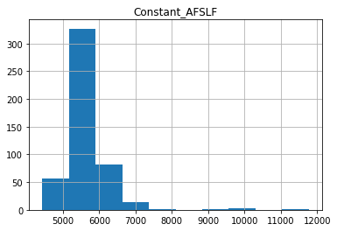 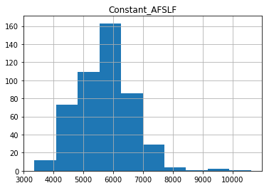

# Appendix E: Model 4 (Private Universities) Residual Plots

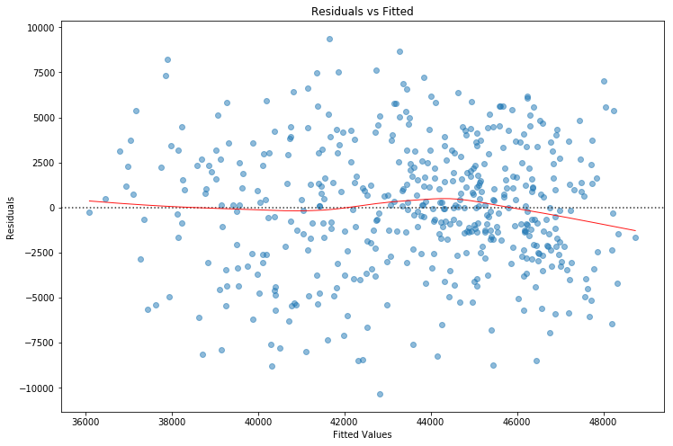

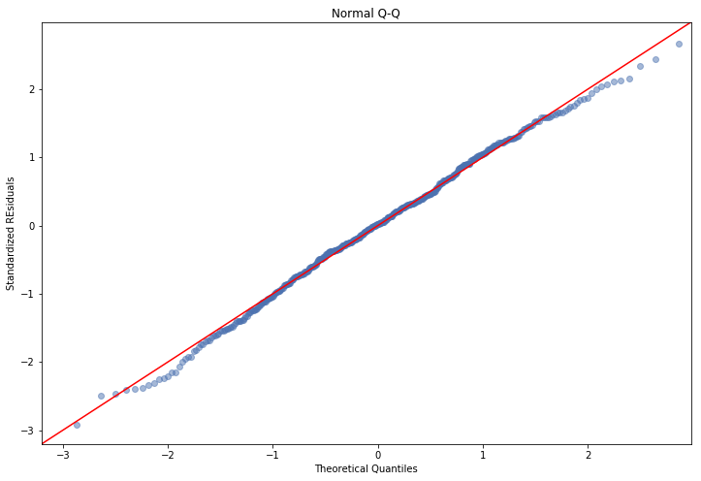

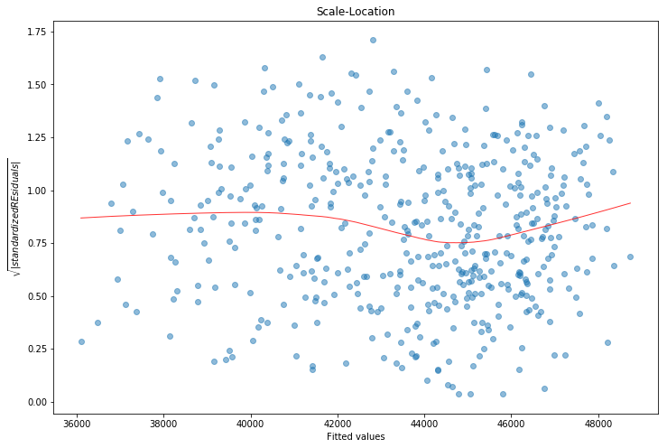

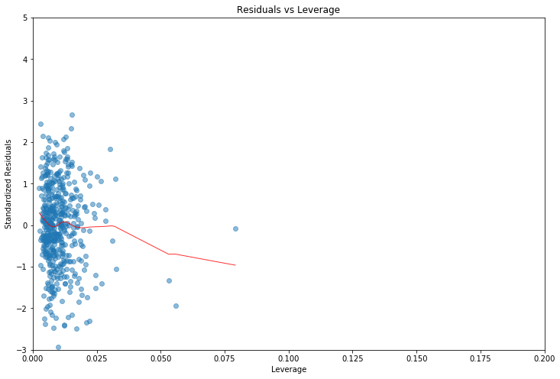

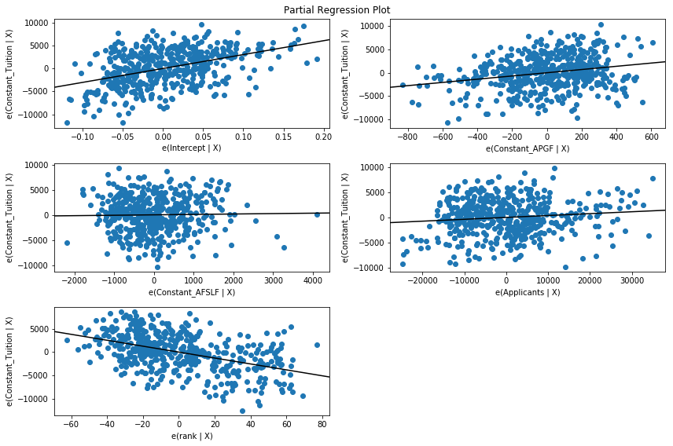

# Appendix F: Model 5 (Public Universities) Residual Plots

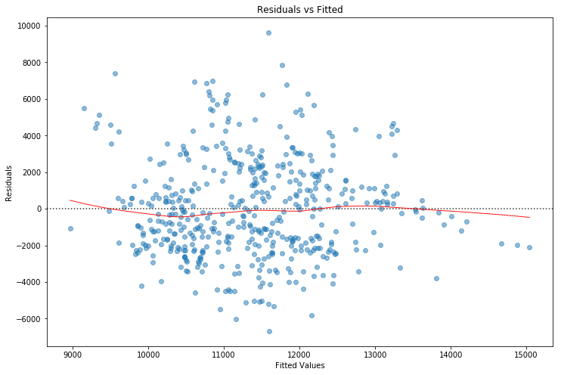

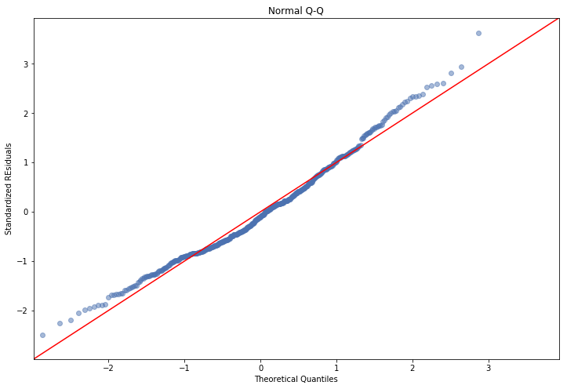

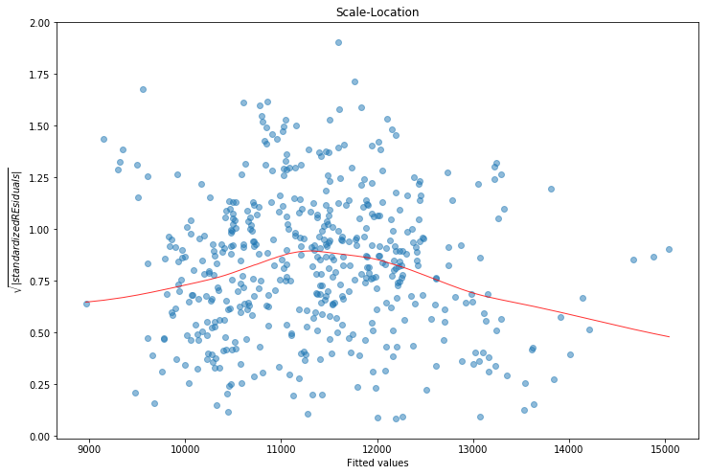

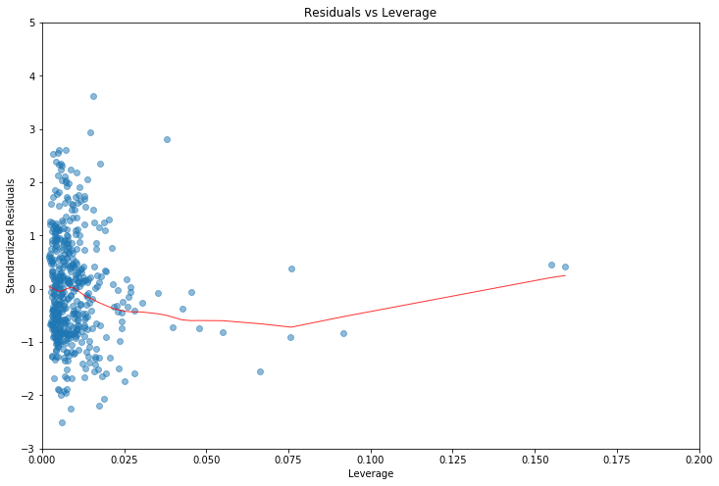

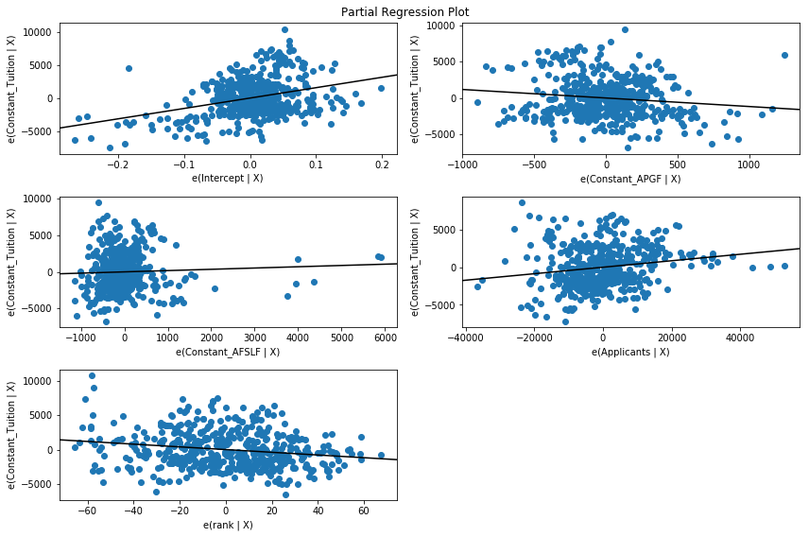

References

Archibald, Robert B., and David H. Feldman. "Does Federal Aid Drive College Tuition." *Regulation* 39 (2016): 12.

De Mello, João MP, and Insper Isabela Ferreira Duarte. "The Effect of the Availabilty of Student Credit on Tuitions: Testing the Bennet Hypothesis using Evidence from a Large-Scale Student Loan Program in Brazil." 2016 Meeting Papers 1451,Society for Economic Dynamics (2016).

Bennett, William J. "Our greedy colleges." New York Times 18 (1987): A27.

Cellini, Stephanie Riegg, and Claudia Goldin. "Does federal student aid raise tuition? New evidence on for-profit colleges." *American Economic Journal: Economic Policy* 6, no. 4 (2014): 174-206.

Gillen, Andrew. "Introducing Bennett Hypothesis 2.0." Center for College Affordability and Productivity (NJ1) (2012).

Kramer, Dennis A., Justin C. Ortagus, and T. Austin Lacy. "Tuition-Setting Authority and Broad-Based Merit Aid: The Effect of Policy Intersection on Pricing Strategies." Research in Higher Education 59, no. 4 (2018): 489-518.

Landry, Lynette, and Deane Neubauer. "The role of the government in providing access to higher education: the case of government-sponsored financial aid in the US." Journal of Education and Work 29, no. 1 (2016): 64-76.

Mohr, A., 2017. The Policy of Federal Student Loans: Looking Backward and Looking Forward. Washington University Journal of Law & Policy, 53, p.341.

Rizzo, Michael, and Ronald G. Ehrenberg. "Resident and nonresident tuition and enrollment at flagship state universities." In *College choices: The economics of where to go, when to go, and how to pay for it*, pp. 303-354. University of Chicago Press, 2004.

Singell Jr, Larry D., and Joe A. Stone. "For whom the pell tolls: The response of university tuition to federal grants-in-aid." *Economics of Education Review* 26, no. 3 (2007): 285-295.